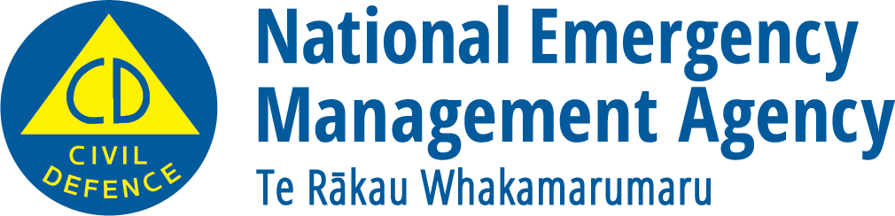
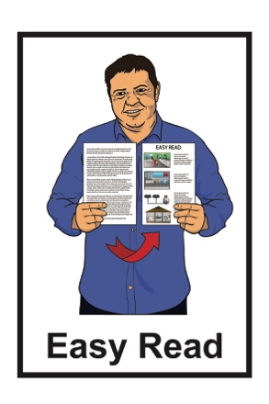

What you can do to be ready

for a hazard

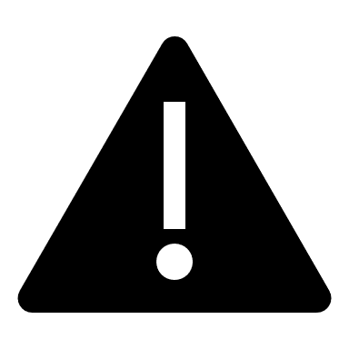

December 2022

What you will find in here

Page number:

What is a hazard? 3

Different types of hazards………..7
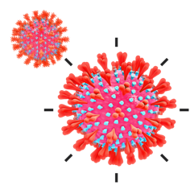

- Pandemic 7
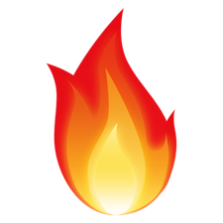

- Fire 9
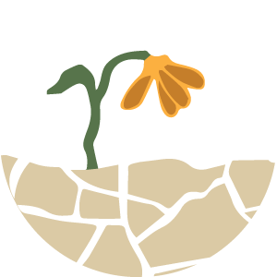

- Drought 11
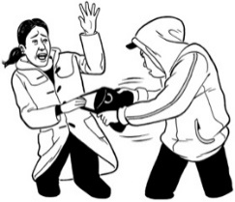

- Criminal acts and terrorism 13

Page number:
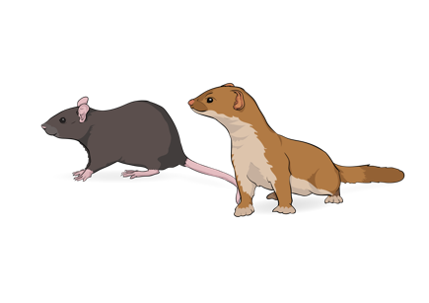

- Animal and plant pests and
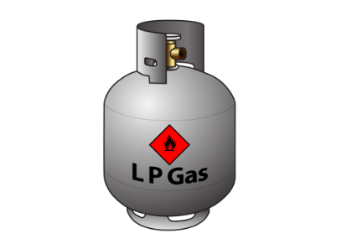
diseases 17

- Hazardous substances 18

What is a hazard?

The information in this booklet is about knowing what to do if you are faced with a hazard.

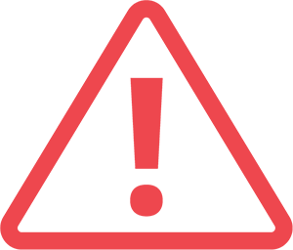
A hazard is something that can:

- cause danger

- put people at risk.

A hazard is also sometimes known as an emergency.

An emergency is when something serious happens that means people need to act quickly to stay safe.

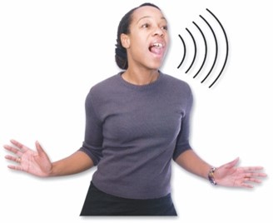
If an emergency happens:

- it can put people in a lot of danger
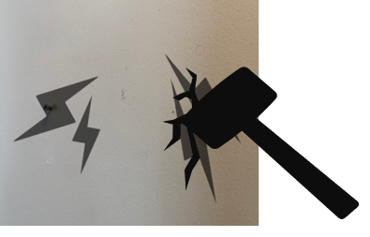
- it can cause a lot of damage.

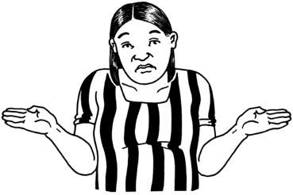
It is not possible to know when an emergency might happen.

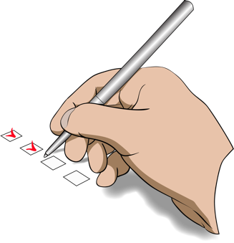
There are things we can do to:

- be ready for hazards
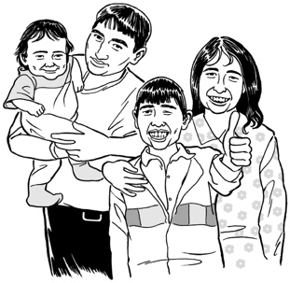
- protect ourselves

- protect our family / whānau.

The best way to be ready for a hazard is to make a plan.

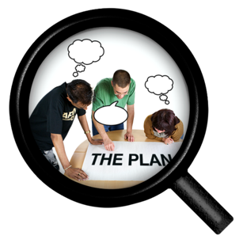
Having a plan will make it easier for you to know what to do in an emergency.

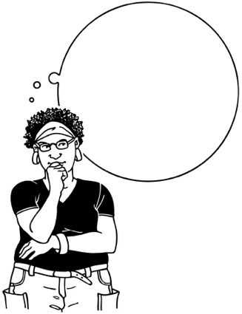
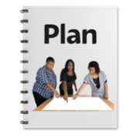
It is important to practise what you will do in an emergency so you can act quickly to keep yourself safe if it happens.

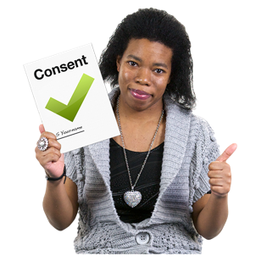
Practise is when you do something many times so that you can get good at doing it.
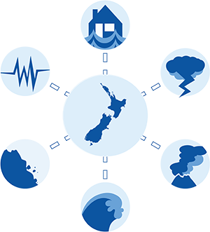

There are lots of different types of hazards / emergencies that can happen in New Zealand.

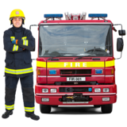
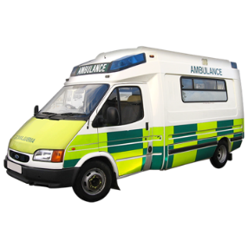
Many different groups of people known as agencies work together to:

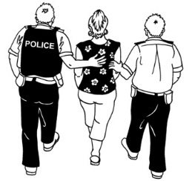
- manage hazards / emergencies

- keep people safe.

There are different agencies for different types of hazards.

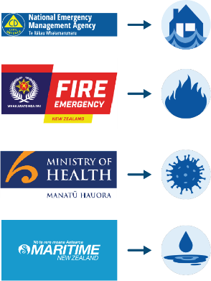
The agency that deals with the hazard depends on the type of emergency it is.

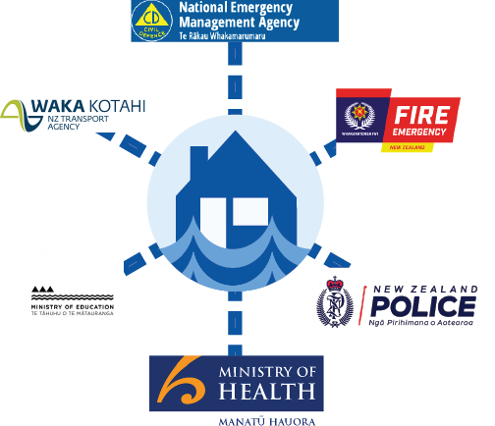
Some types of hazards / emergencies need more than 1 agency to support people when the emergency happens.

Different types of hazards

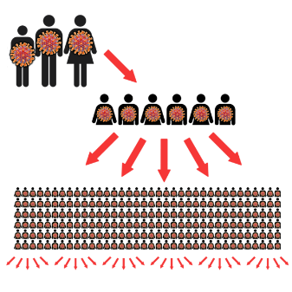
- Pandemic

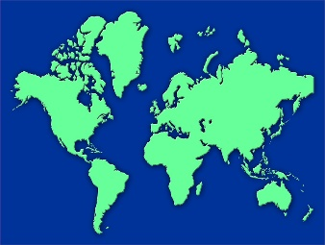
A pandemic happens when a virus spreads very quickly around:
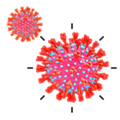
- many countries around the world.
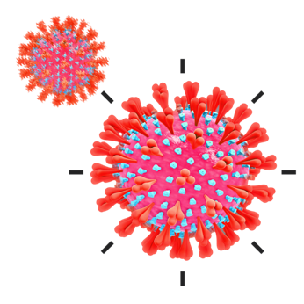

A virus is something that can make people sick.

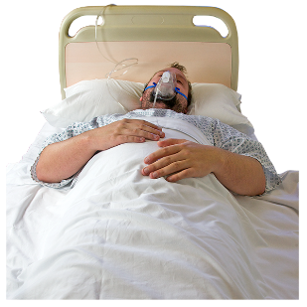
A pandemic can make a lot of people very sick very quickly.

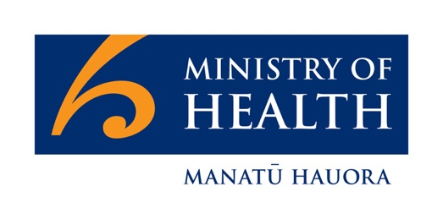
The Ministry of Health is the agency in New Zealand that deals with:

- how to plan for a pandemic

- what to do if a pandemic happens.

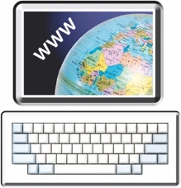
You can find more information about the Ministry of Health at their website:

https://www.health.govt.nz

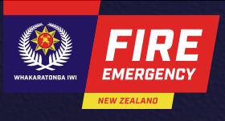
- Fire

Fire and Emergency New Zealand is the agency that deals with fire hazards.

You can find more information about Fire and Emergency New Zealand at their website:

https://www.fireandemergency.nz

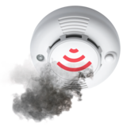
You should call 111 straight away if you see any signs of a fire such as:

- smoke

- flames.

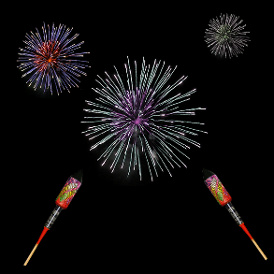
Some fires can be caused by things that humans do such as:

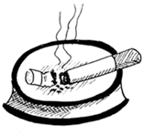
- not using fireworks safely

- not putting out cigarettes properly

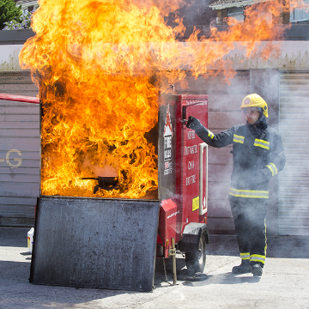
- letting fires they have started get out of control like:

- campfires

- rubbish fires

- bonfires.

Other causes of fires are things like:

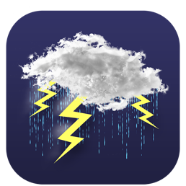
- car accidents

- lightning strikes
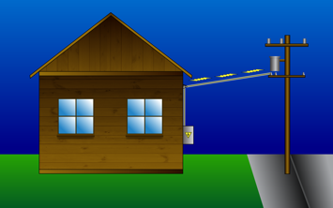
- problems with electrical power lines.

3. Drought

A drought is when an area does not have as much water as it should have.

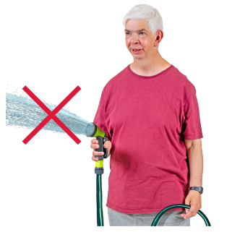
A drought can:

- affect the water supply that people need to use

- make any risk of fire more dangerous.

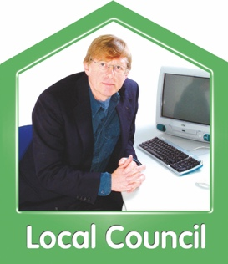
Your local council will be able to give you more information about droughts where you live.

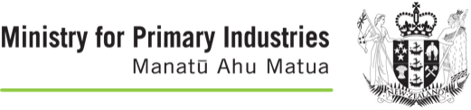
The Ministry for Primary Industries is the agency that deals with droughts.
You can find more information about the Ministry for Primary Industries at their website:

https://www.mpi.govt.nz

- Criminal acts and terrorism

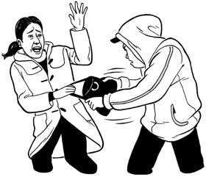
A criminal act is when a person does something that means they are breaking the law.

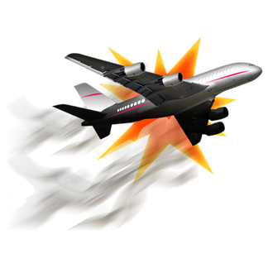
Terrorism is when someone who is part of a political group uses violence against others to try and force people to do things.

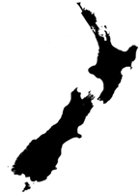
New Zealand is mostly a safe country

but
it is not completely free from crime.

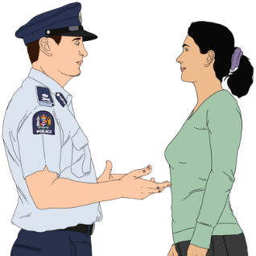
The New Zealand Police support people with many different types of emergencies including those that affect New Zealand as a country.
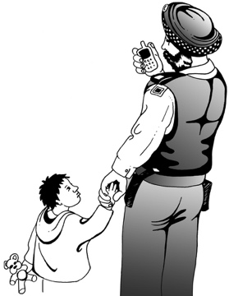
The job of the New Zealand Police is to:

- make sure that everyone follows New Zealand laws

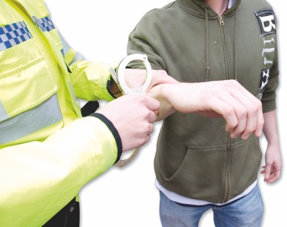
- help keep everybody safe

- work to prevent crime.

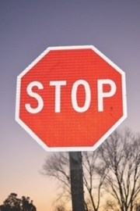
Prevent means to stop something from happening.

It is also important that you:
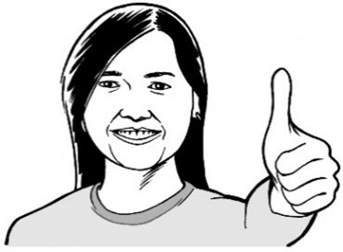
- look after yourself

- keep yourself safe from crime.

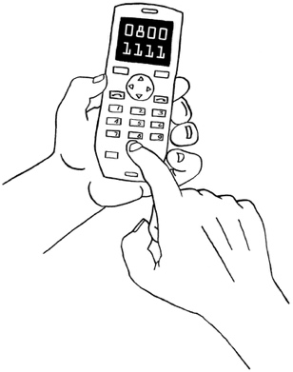
You should always call 111 if there is a serious risk to any person or property.
Your property could be things like:

- the outside of your house
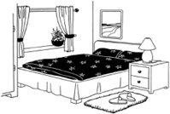
- things inside your house

- your car

- things in your garden such as a shed.

You should call 105 to report things that:
- have already happened

- do not need the Police to come straight away.
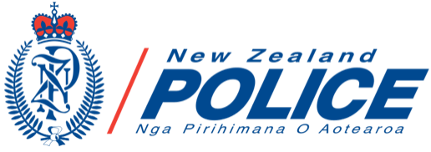
You can find more information about the New Zealand Police at their website:

https://www.police.govt.nz

- Animal and plant pests and diseases

The Ministry for Primary Industries is the agency that looks after the biosecurity of New Zealand.

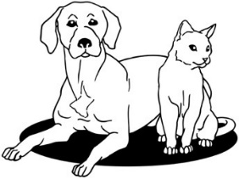
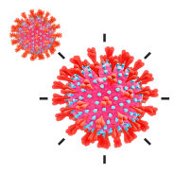
Biosecurity is how we protect a country from living dangers such as:
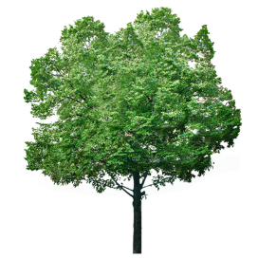
- diseases in animals

- diseases in plant life

- pests of many different types.
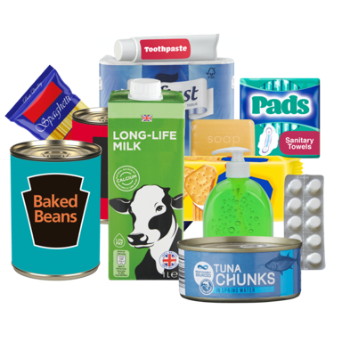
The Ministry for Primary Industries
also makes sure that all our food is safe to eat.

- Hazardous substances

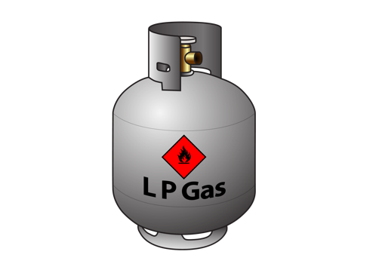
A hazardous substance is any product / chemical that can be:

- explosive which means it can cause an explosion
- flammable which means it can easily catch fire
- oxidising which means it can speed up the spread of a fire

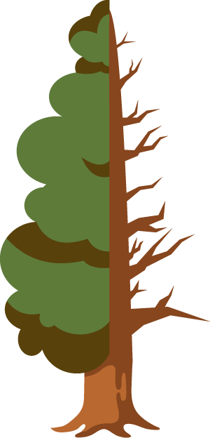
- corrosive which means it can damage other substances it touches

- toxic to the environment which means it can poison living things.

Fire and Emergency New Zealand is the agency that deals with emergencies caused by hazardous substances.

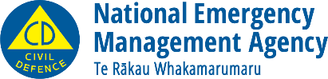
This information has been written by the National Emergency Management Agency.
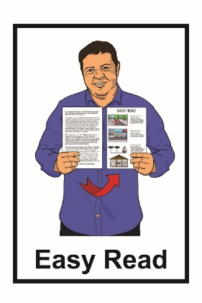
It has been translated into Easy Read by the Make It Easy service of People First New Zealand Inc. Ngā Tāngata Tuatahi.

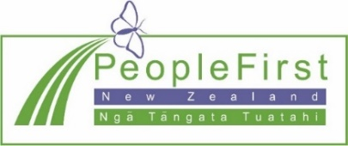
The ideas in this document are not the ideas of People First New Zealand Inc. Ngā Tāngata Tuatahi.
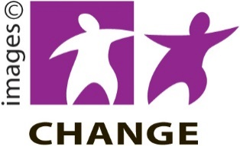
Make It Easy uses images from:

- Changepeople.org

- Photosymbols.com
- Sam Corliss
- Huriana Kopeke-Te Aho

All images used in this Easy Read document are subject to copyright rules and cannot be used without permission

