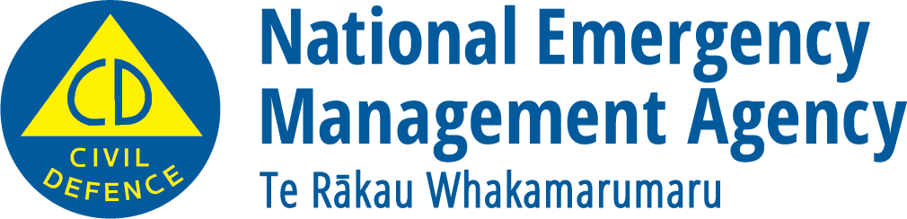
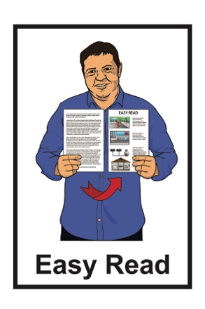

Getting ready for an emergency:

My household plan
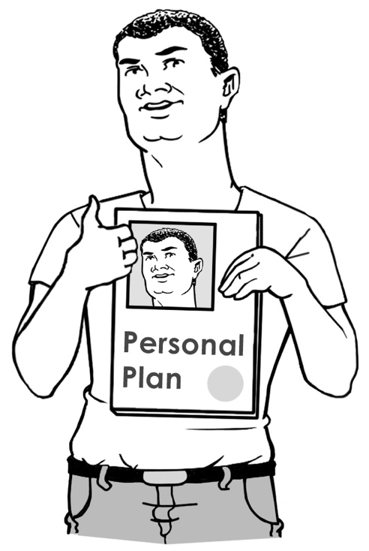
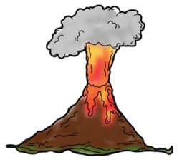
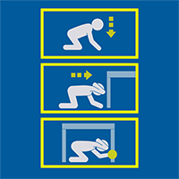
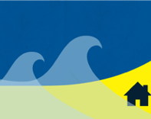

December 2022

My emergency plan

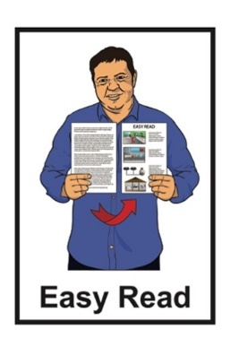
This document is an Easy Read tool to support you to make an emergency plan for you / your household.

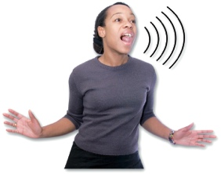
An emergency is when something dangerous happens that can put people at risk.

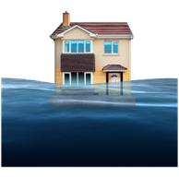
An emergency can be things like:

- a flood
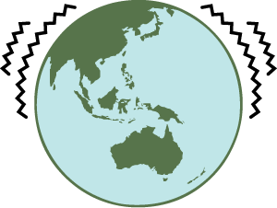
- an earthquake

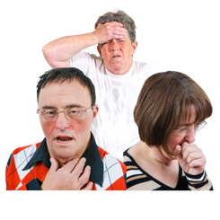
- a pandemic which is when a lot of people get very sick very quickly.

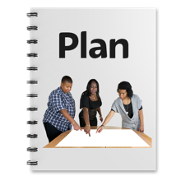
Having a plan for if an emergency happens will make it much easier for you to get through it.

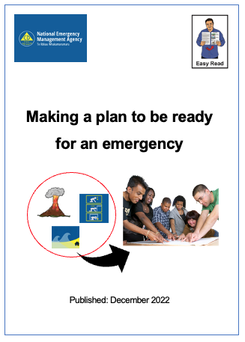
You can also find more information about making an emergency plan in the Easy Read document called:
Making a plan to be ready for an emergency

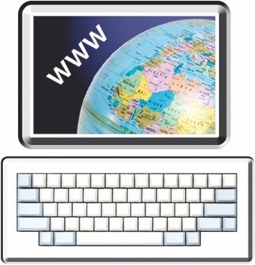
You can find this document on this website:

www.getready.govt.nz

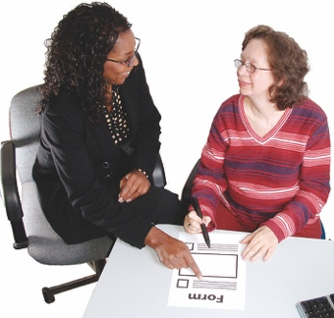
You can ask someone to support you with filling out your plan like a:
- whānau / family member
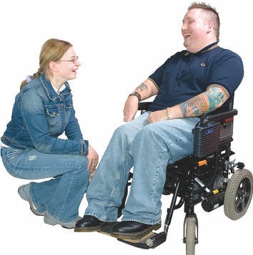
- friend

- neighbour

- support worker.

Information about me

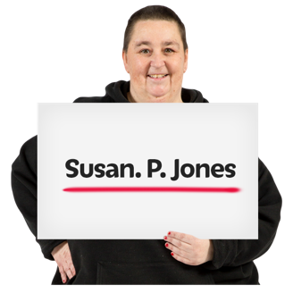
My name is:

______________________________

My home telephone number is:

______________________________
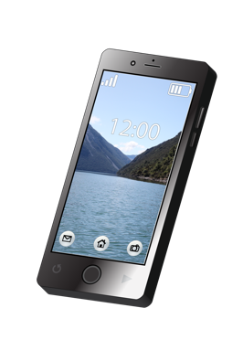

My mobile telephone number is:

______________________________

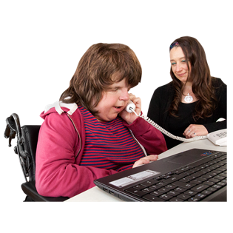
My work telephone number is:

______________________________

Information about the people I live with

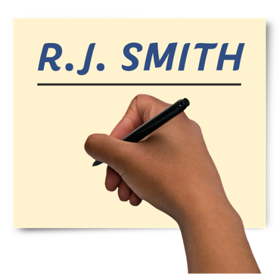
Put information about the people you live with on this page.

Their name is:

______________________________

The best phone number to contact them on is:

______________________________

You can add more information on the next 2 pages.

Information about the people I live with

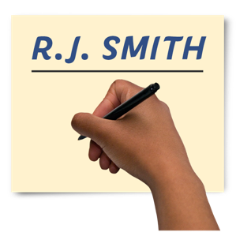
Their name is:

______________________________

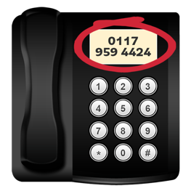
The best phone number to contact them on is:

______________________________

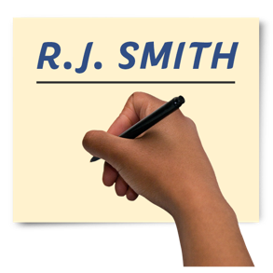
Their name is:

______________________________

The best phone number to contact them on is:

______________________________

Information about the people I live with

Their name is:

______________________________

The best phone number to contact them on is:

______________________________

Their name is:

______________________________

The best phone number to contact them on is:

______________________________

Where will we go if we cannot get home?

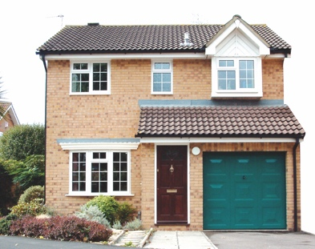
The place we will go in an emergency if we cannot get home is:

- the address of meeting place:

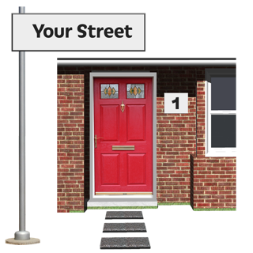
______________________________

______________________________

______________________________

______________________________

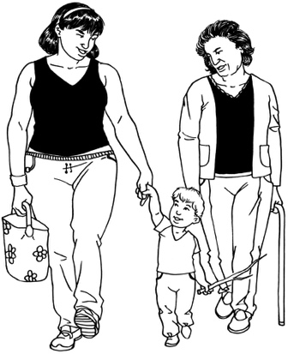
We will get to our meeting place by:
______________________________

______________________________
______________________________

Who will pick up the children?

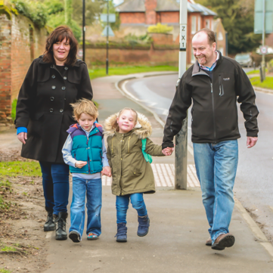
If we cannot get to the school / early childhood centre 1 of the people on this list will go to / get the children.

Their name is:

______________________________

The best phone number to contact them on is:

______________________________

You can add more information on the next page.

Who will pick up the children?

Their name is:

______________________________

The best phone number to contact them on is:

______________________________

Their name is:

______________________________

The best phone number to contact them on is:

______________________________

If we cannot get in touch with each other

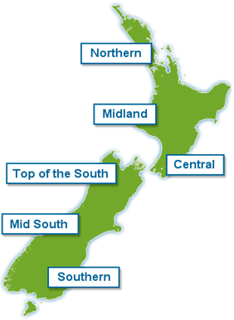
We will check in with someone who is outside of our local area if:
- the phone lines stop working
- we cannot get in touch with each other.

The person we will get in touch with is:

______________________________

The best way to get in touch with them is:

______________________________
You can add more on the next page.

If we cannot get in touch with each other

The person we will get in touch with is:

______________________________

The best way to get in touch with them is:

______________________________

The person we will get in touch with is:

______________________________

The best way to get in touch with them is:

______________________________

Where will we get updates?

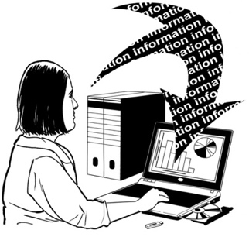
We will keep up to date about what is happening in an emergency at these places:

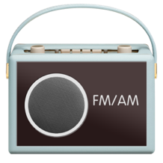
- radio stations:
______________________________

______________________________
______________________________

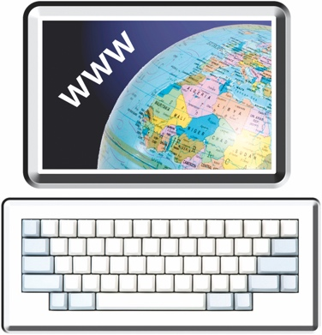
- websites:
______________________________

______________________________
______________________________
You can add more on the next page.

Where will we get updates?

We will keep up to date about what is happening in an emergency at these places:

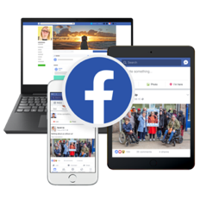
- social media:
______________________________
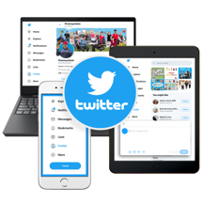
______________________________
______________________________
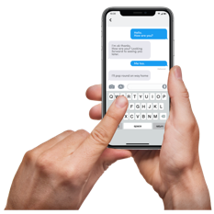
- other places we can get information:
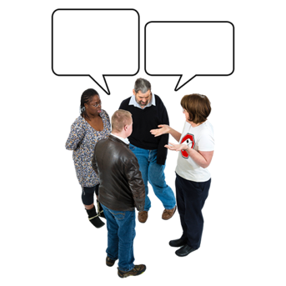
______________________________

______________________________
______________________________

Who might need our support?
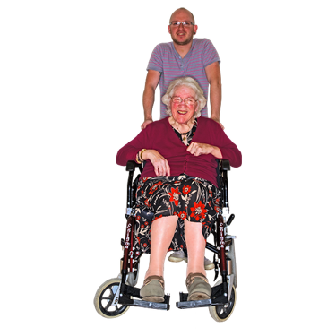

In an emergency:

- we might need support
- other people might need support.

People who might need support are:

Their name is:

______________________________

The best way to get in touch with them is:

______________________________

You can add more on the next page.

Who might need our support?

People who might need support are:
Their name is:

______________________________

The best way to get in touch with them is:

______________________________

Their name is:

______________________________

The best way to get in touch with them is:

______________________________

Who might support us?

People who might support us are:

Their name is:
______________________________

The best way to get in touch with them is:

______________________________

Their name is:

______________________________

The best way to get in touch with them is:

______________________________

Who will I need to contact?

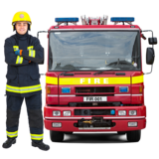
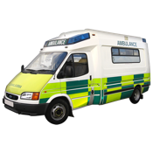
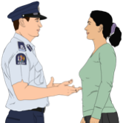
The number to call for emergency services is:
1 1 1
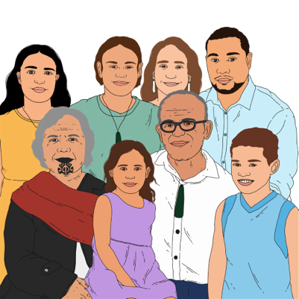
In an emergency you may need to contact people like:
- your family / whānau
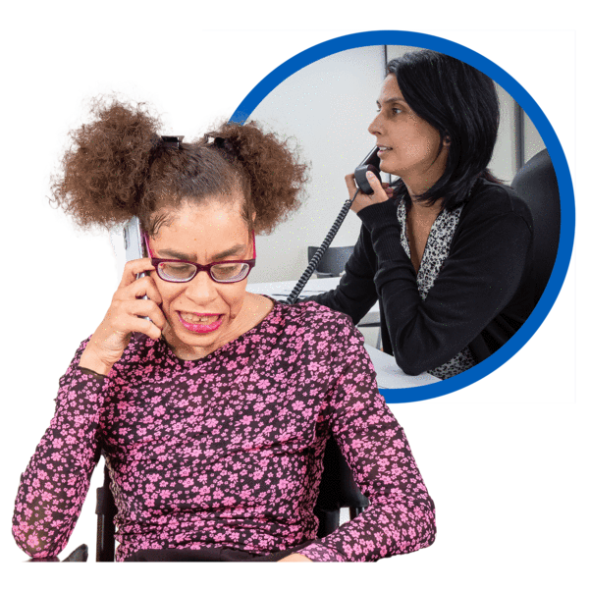
- the school your child goes to
- your landlord
- your doctor / medical centre.
Put the contact information for these people on the next 2 pages.

Who will I need to contact?

Their name is:

______________________________

The best way to get in touch with them is:

______________________________

Their name is:

______________________________

The best way to get in touch with them is:

______________________________

Who will I need to contact?

Their name is:

______________________________

The best way to get in touch with them is:

______________________________

Their name is:

______________________________

The best way to get in touch with them is:

______________________________

If you are stuck at home

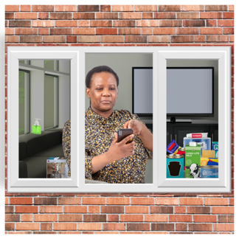
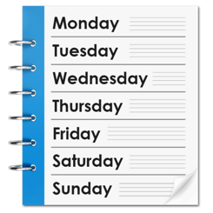
If the emergency is very bad you may have to stay at home without a way to get supplies for at least 3 days.

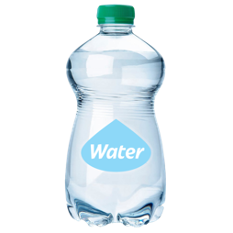
Supplies could be things like:

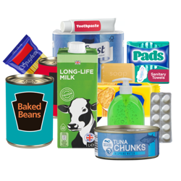
- a stock of bottled water for everyone in your house

- a cupboard stocked with food
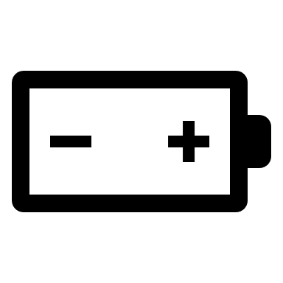
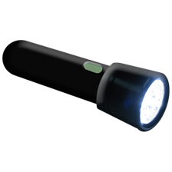
- a torch with extra batteries
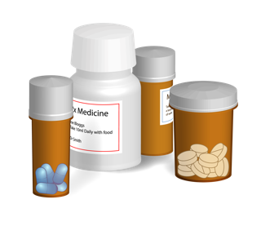
- any medicines you need.

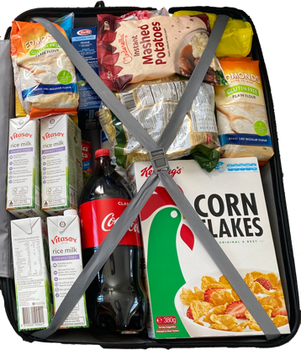
You should make sure you have supplies for at least 3 days.
Our emergency supplies are kept in this place:
______________________________

______________________________
______________________________
______________________________
If the power / electricity goes off you might have to find things in the dark.

Where to find a torch:
______________________________

______________________________

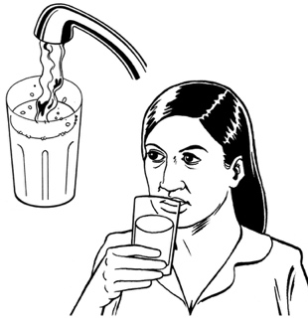
An emergency could mean you need to turn off some utilities like:
- your water supply
- your gas supply.

How to turn off the water supply:

______________________________

______________________________

______________________________

How to turn off the gas supply:

______________________________

______________________________

______________________________

If the power / electricity stops working

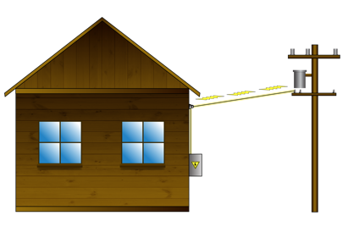
An emergency could cut off the power / electricity supply.

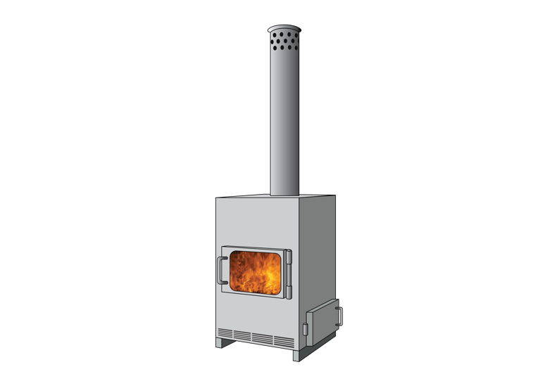
If we do not have any electricity / power we will:
- keep warm by:
______________________________

______________________________

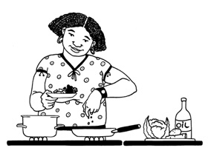
______________________________
- cook things with:

______________________________

______________________________
______________________________
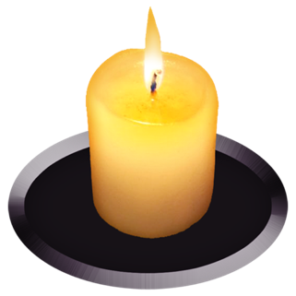
If we do not have any electricity / power we will use these things to
see when it gets dark:
______________________________

______________________________
______________________________
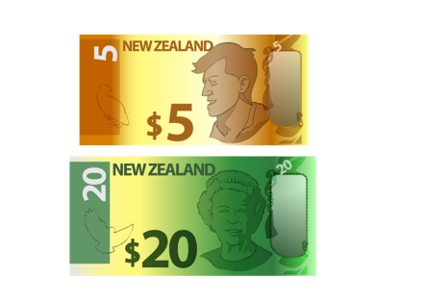
Put a tick like this in the box to show you have:
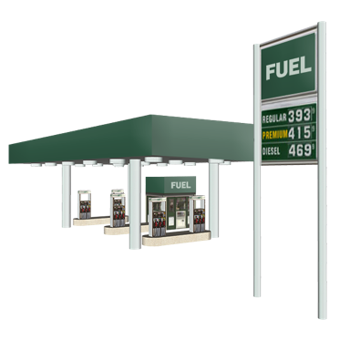
enough money in the house in case cash machines stop working
enough fuel in your car / vehicle in case petrol pumps stop working.

If the water supply stops working

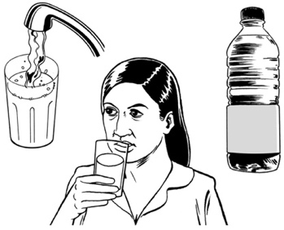
An emergency could:

- make your water supply unsafe to use
- cut off your water supply.

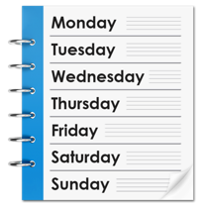
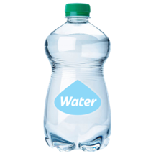
You should make sure you have a supply of water that will last you at least 3 days.

You should make sure you also store plenty of water you can use for:
- cooking
- cleaning.

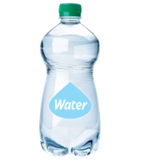
How much water we have stored:
______________________________

______________________________

The stored water is kept in this place:
______________________________

______________________________

Put a tick like this in the box to show you have extra water stored for:
cooking
cleaning.
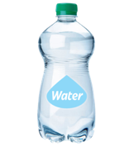
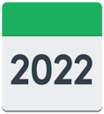
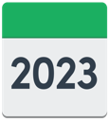
Remember to change your stored water every year.
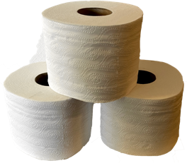
We will use these things for a toilet if the water supply stops working:
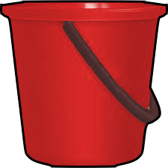
______________________________

______________________________
______________________________

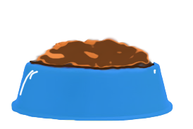
We have water stored for pets / other animals in this place:
______________________________

______________________________
______________________________

If we need to leave home in a hurry
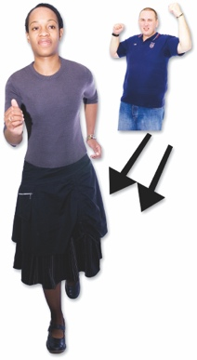

An emergency may mean you need to leave home in a hurry.

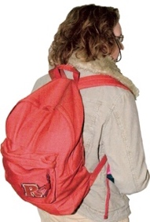
You should have a grab bag for every person in your house.

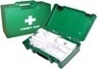
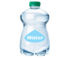
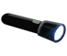
A grab bag is a small backpack of essential items.

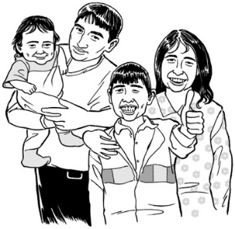
Everyone can find their grab bags in this place:
______________________________
______________________________
______________________________

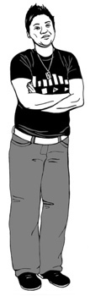
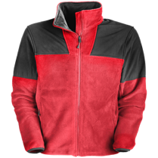
Put a tick like this in the box to show you have put these things in your grab bag:

some warm clothes

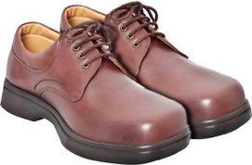
some sturdy shoes you can walk in

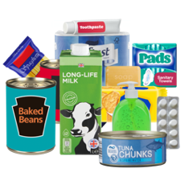
a bottle of water

some food / snacks
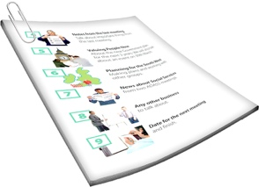
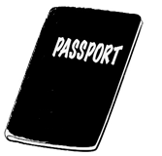
copies of important documents like bank account / insurance details
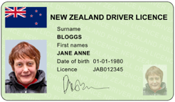
copies of photo ID like your passport / driver licence.
Put a tick like this in the box to show you have put these things in your grab bag:

any medicines you may need
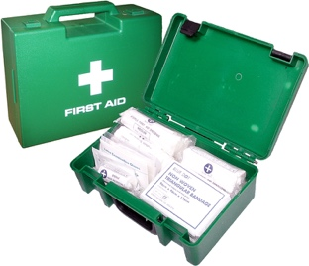

a first aid kit
a torch and spare batteries
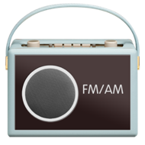
a radio.

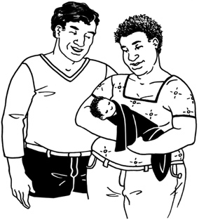
Make sure you think about people who have special needs like:
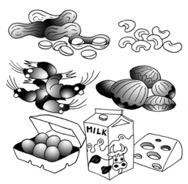
- babies
- people who need to eat special food.
Write down any other things you have put in your grab bag:
______________________________

______________________________
______________________________

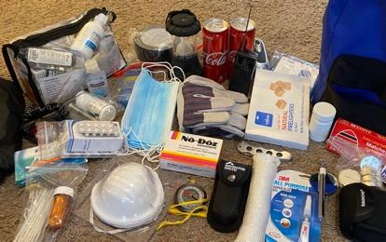
______________________________

______________________________
______________________________

______________________________

______________________________
______________________________

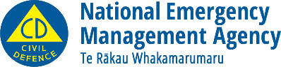
This information has been written by the National Emergency Management Agency.
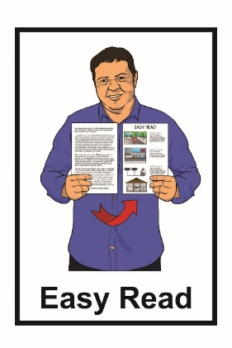
It has been translated into Easy Read by the Make It Easy service of People First New Zealand Inc. Ngā Tāngata Tuatahi.

The ideas in this document are not the ideas of People First New Zealand Inc. Ngā Tāngata Tuatahi.
Make It Easy uses images from:

- Changepeople.org

- Photosymbols.com

- Sam Corliss
- Huriana Kopeke-Te Aho

All images used in this Easy Read document are subject to copyright rules and cannot be used without permission.

